Art Brut

*Art brut* is a term and phenomenon created by the French artist and writer Jean Dubuffet (1901-1985). It refers to works of art created by artists who seemed to stand outside of culture—or more specifically the art world and its institutions. Dubuffet sought a kind of art more radical than the avant-garde, which he thought had become increasingly homogenous and empty of invention. Modern artists no longer provided a sufficient critique of culture, so his search for a new and revolutionary art led him to fringes of society. *Art brut* translates to “raw art,” as Dubuffet viewed this kind of art to be “uncooked” by culture. He looked for works which owed “nothing to the imitation of art that one can see in museums, salons, and galleries; works which the artist has entirely derived (invention and manner of expression) from his own sources, from his own impulses and humours, without regard for the rules, without regard for current convention” *(Prospectus et tous écrits suivants,* 1967). *Art brut* artists were often eccentric personalities, psychiatric patients, non-professional artists, and prisoners. Most importantly, these artists created works which aimed to express the maker’s pure, unmediated vision, without any knowledge of or regard for previous traditions. Therefore, *art brut* creations are not unified in terms of formal qualities or medium, but rather by the status of the creator.

*Art brut* was primarily a mid-twentieth-century European phenomenon. Dubuffet first began formulating the concept of *art brut* in the summer of 1945 when he began travelling through Switzerland and France. Dubuffet was deeply affected by the work of the Swiss psychiatrist and art historian Hans Prinzhorn (1886-1993), who collected work made by psychiatric patients. This collection led to Prinzhorn’s writing of his most important text, *Bildnerei der Geisteskranken* [*Artistry of the Mentally Ill*] in 1922. The text served as an inspiration and a starting point from which Dubuffet could begin conceptualizing the beginnings of *art brut.* It was during these trips that Dubuffet became acquainted with artists who would later become important figures in *art brut*, such as Adolf Wölfli (1864-1930) and Alöise Corbaz (1886-1964), both Swiss. Dubuffet also formed many important friendships with various figures who became collaborators and facilitators. Dubuffet conducted most of his research from 1945-1947. He then returned to Paris and founded the *Foyer de l’Art Brut* in the basement of *Galerie René Drouin.* The gallerist and art dealer René Drouin, who was known for mounting exhibitions of then little-known artists such as Wassily Kandinsky and Georges Rouault, was the first person to exhibit works by *art brut* artists. In addition, Dubuffet wanted to publish a journal of his findings, *L’Art Brut*, but only one issue was ever printed, and it was never distributed. In 1948 he founded a more formal venture, the *Compagnie de l’Art Brut*, whose members included Surrealist André Breton and critic Michel Tapié. This non-profit organization was dedicated to the collection and display of *art brut.*

Despite these efforts, the *Compagnie de l’Art Brut* more or less dissolved in 1951, and *art brut* became primarily Dubuffet’s personal obsession. Over time, Dubuffet relaxed his initial definition of *art brut,* which stipulated that authentic artifacts must be made by creators who were completely isolated from culture and any outside influence. Dubuffet realized that no person could be positioned as totally outside of culture or impervious to the external world. In 1971 he donated his collection, around 5,000 objects, to the city of Lausanne, Switzerland. It took five years for the collection to become public. It was inaugurated in 1976 as the *Collection de l’Art Brut* at the Chateau de Beaulieu. The *Collection* remains at this location and is open to the public, serving as an important research center for the study and display of *art brut.*

Dubuffet’s writings and actions were often rife with contradiction. Though he searched for artists who had no formal training or institutional affiliation, his efforts to popularize them often resulted in appealing for institutional recognition. The establishment of the *Compagnie* and the *Collection* resulted in the assimilation of *art brut* into the very art world Dubuffet had fought against. In addition, *art brut* has been the focus of many exhibitions at esteemed art institutions such as the Musée des Artes Décoratifs and the Palais de Tokyo, both in Paris. Paradoxically, for *art brut* to be recognized as such, it needs validation from an agent within the art world, such as Dubuffet. *Art brut* artists cannot be so self-aware that they recognize their production as art, because to do so would destroy the myth of authentic creation.

*Art brut* can be seen as one manifestation of the modernist project to find the primitive or pure origins of art-making. This desire to find the supposed authentic source of art necessitated searching for artists who were perceived as being devoid of culture, whether those artists were from so-called primitive societies or were mentally ill persons marginalized within European cultures. The birth of *art brut* can also be understood as a response to and rejection of modernization and industrialization, as these artists often crafted objects by hand out of the most basic materials: rocks, shells, wood, and even spit. As these artists seemed to retreat into themselves and away from the outside world, they could resist the normalizing pressures of modern society. Some of the most famous *art brut* artists include Gaston Chiassac (1910-1964, French), Madge Gill (1882-1961, British), and Heinrich Anton Müller (1865-1930, French).

In 1972 the British art historian Roger Cardinal coined the term “outsider art” as an English-language translation for *art brut*. Though initially seen as a translation or synonym, outsider art is a distinct phenomenon; it may be more appropriate to view *art brut* as its historical forebear, since *art brut* set the precedent for the collection and exhibition of outsider art in the twentieth and twenty-first centuries. Outsider art has now gained increasing popularity, and sustains its own set of collectors, markets, and institutions. However, the boundaries between outsider art and *art* *brut* remain unclear, as many *art brut* artists are classified as outsiders and vice-versa.

**References and further reading:**

Cardinal, Roger. (1972). *Outsider art*. New York: Praeger Publishers.

Dubuffet, Jean. (1988). *Asphyxiating culture and other writings*. New York: Four Walls Eight

Windows.

Prinzhorn, Hans. (1972). *Artistry of the Mentally Ill: a contribution to the psychology and*

*psychopathology of configuration.* New York: Springer-Verlag.

Peiry, Lucienne. (2006). *Art Brut: the Origins of Outsider Art.* Paris, Flammarion.

Thévoz, Michel. (1976). *Art Brut.* New York: Rizzoli.

Dubuffet Foundation website:

<http://www.dubuffetfondation.com/index_ang.htm>

Collection de l’Art Brut website:

<http://www.artbrut.ch/en/21070/collection-art-brut-lausanne>

ABCD, a non-profit organization dedicated to the awareness of *art brut*:

[http://www.abcd-artbrut.net](http://www.abcd-artbrut.net/)

“Anticultural Positions,” a lecture given by Jean Dubuffet at the Arts Club of Chicago, Thursday December 20, 1951:

<http://www.neiu.edu/~wbsieger/Art201/201Read/201-Dubuffet.pdf>

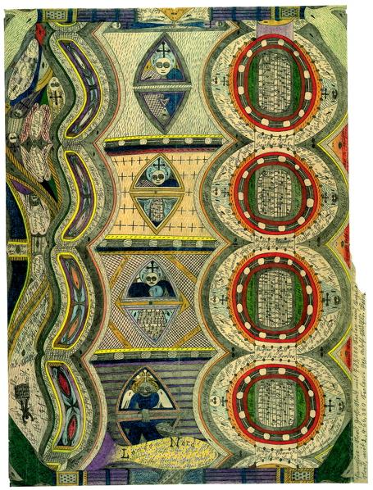

Adolf Wölfli. *London-North*, 1911. Graphite and colored pencil on paper. Adolf Wölfli Foundation, Museum of Fine Arts, Bern, Switzerland.

<http://www.adolfwoelfli.ch/index.php?c=showPic&lang=e&level=17&sublevel=0&id=129&parent_id=43>

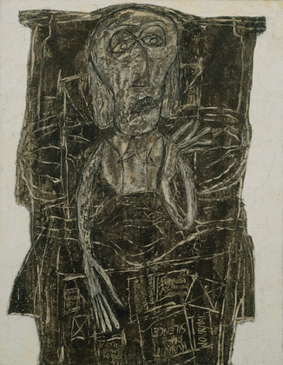

Jean Dubuffet. *Joe Bousquet in Bed*, 1947. Oil emulsion and water on canvas, 57 5/8 x 44 7/8" (146.3 x 114 cm). Museum of Modern Art, New York; Mrs. Simon Guggenheim Fund.

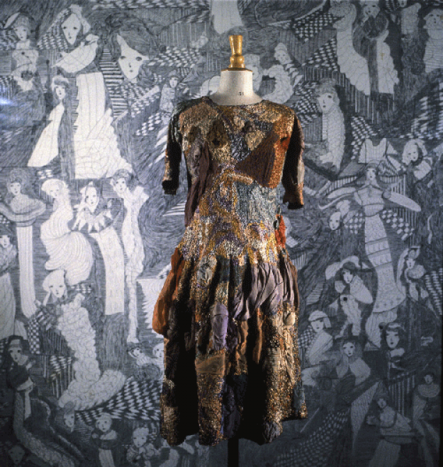

Madge Gill, *Untitled,* undated. dress embroidered with mercerized cotton thread and wool enriched with cotton voile, height 93 cm. *Collection de L’Art Brut*, Lausanne, Switzerland.